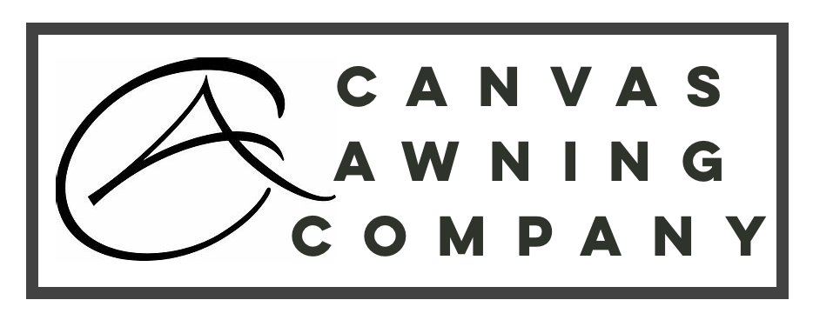
Warranty
Our Awnings are covered by a 12-month manufacturer’s warranty against manufacturing defects.
When you receive your order, you should always go through the entire shipment to check if there are missing or damaged parts. Canvas Awning Company will only cover costs of the 1st shipment to replace any missing or damaged parts. Therefore, you should make sure to have checked everything before contacting our warranty department.
Canvas Awning Company’s warranty applies only to the normal use of the product, normal wear and tear excepted, in accordance with written use instructions or manual, if any, provided with the product (either in writing or through a hyperlink to such instructions/manual).
The warranty does not cover normal wear and tear. Neither does it cover damage, defect, wear and tear caused by misuse, poor maintenance, abuse, unauthorized modification or exposure to adverse weather, wind, rain, snow or other forces of nature, accidents, improper assembly or dis-assembly or adjustment during set-up or take down, or any abuse, misuse or neglect by the user.
Our Awnings are not permanent structures. They are intended as a temporary form of coverage to be used on an occasional and non-permanent basis only. Awnings should not be left unattended for prolonged periods of time.
We do not advise you assemble or disassemble your Awning during adverse windy weather conditions. Damage caused by incorrect use or incorrect anchoring of awnings in severe weather or through improper use is not covered by our warranty.
Depending on the specific situation and if the claim is justified, the Canvas Awning Company warranty will cover either repair of the product, exchange to a new product, a money refund or price reduction.

